NPARC

The Amateur Radio Club for

the Watchung Hills Area

In cooperation with the Berkeley Heights Recreation Commission
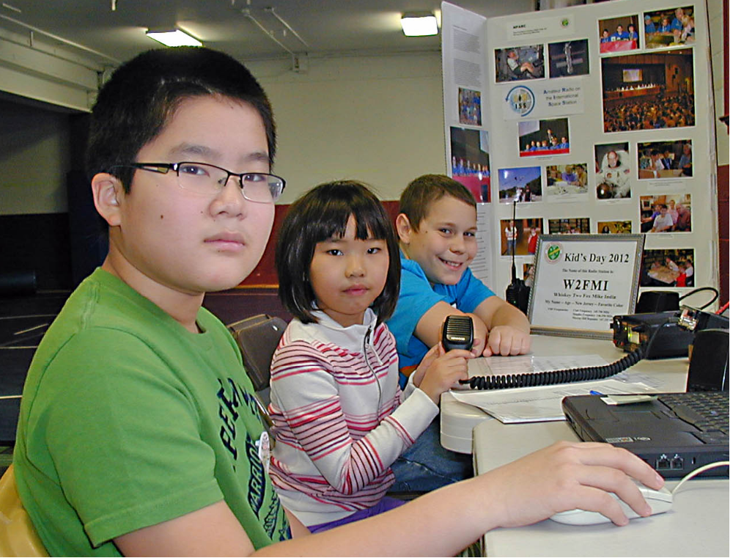
and the New Providence Recreation Department

Presents “Ham Radio KIDS DAY”

A chance for kids of all ages to operate a Ham Radio Station and speak with other kids from all over the USA and Canada, and possibly from all over the world!

This event takes place on Sunday January 5, 2014 at the
Berkeley Heights Community Center, 29 Park Avenue next to the Town Hall, between 2:00 PM and 5:00 PM

No experience required. Just show up at any time in the afternoon.

Licensed Radio Amateurs from NPARC will set up the station starting at noon, and will be available to answer any questions which you or your parents may have.

For information call:
Barry Cohen K2JV, 908-464-1730 (anytime)
Paul Campano N2KDK, 908-508-9595
Or go to: www.nparc.org

